FIG 1 – (Finalizing 300 dpi image of map cites w/ Ping, will look similar to this but better)
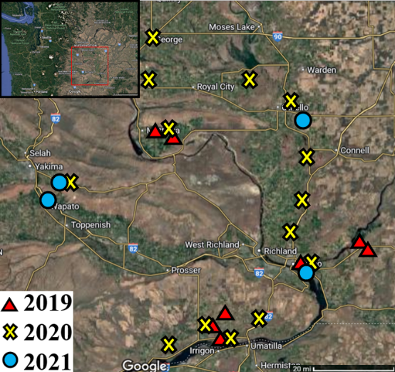
Figure 1. Map. Collection sites for N. tenellus by year.

FIG 2 - 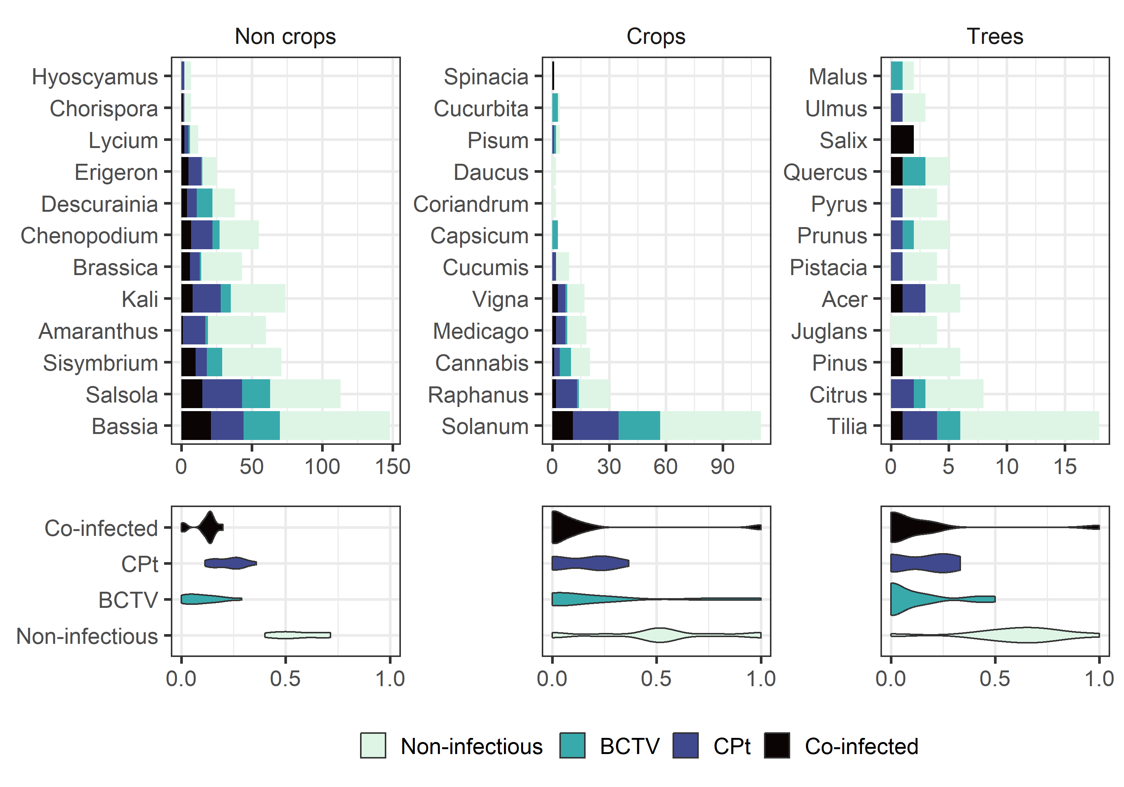
Figure 2. Neoaliturus tenellus Gut Content Analysis. Counts of plant genera in individual N. tenellus gut contents, categorized into three groups: non-crops (or weeds), crops, and trees. The x-axis represents the count of leafhoppers in which each plant type was detected, while the y-axis lists the plant genera identified. The lower panel shows the distribution of infection status across the three plant groups. Co-infection refers to the presence of both ‘Candidatus Phytoplasma trifolii’ (CPt) and beet curly top virus (BCTV).

FIG 3 - 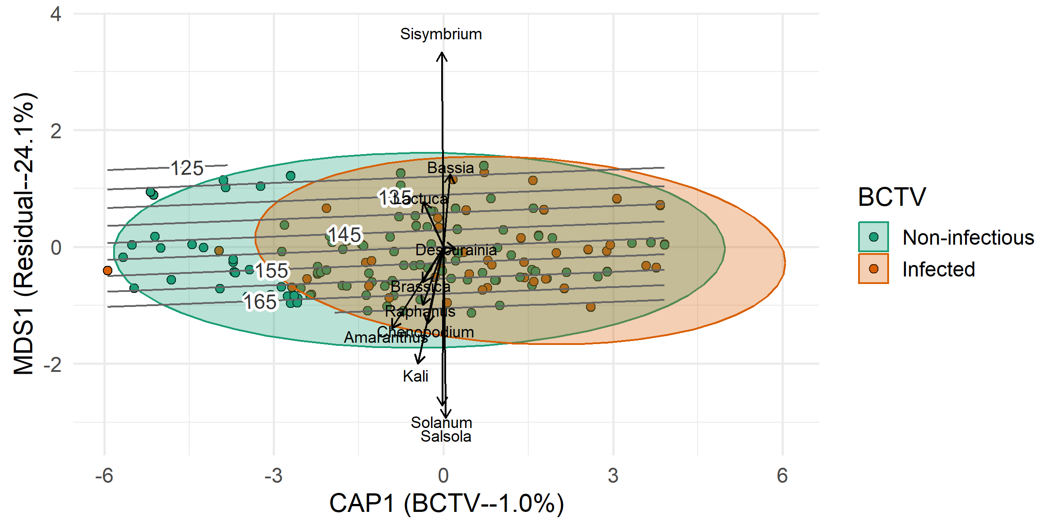
Figure 3. Canonical Analysis of Principal Coordinates for gut contents. CAP1 represents variation in gut content plant community composition constrained to show separation by BCTV infection status. MDS1 represents the first major axis of residual (unconstrained) variation in community composition. Points are individual N. tenellus gut assays. The direction of species vectors indicates increases in relative abundance across the ordination space, while the length of the vector indicates the strength of correlation between each species and variation in ordination space. Vectors aligned with CAP1 would indicate collinearity with BCTV infection. Vectors orthogonal to CAP1 indicate species whose abundances are primarily independent of BCTV infection. Grey isoclines represent sampling date across the growing season and are generated by a GAMM surface overlay. Numbers on isoclines are the day of year from 1 January.
FIG 4 - 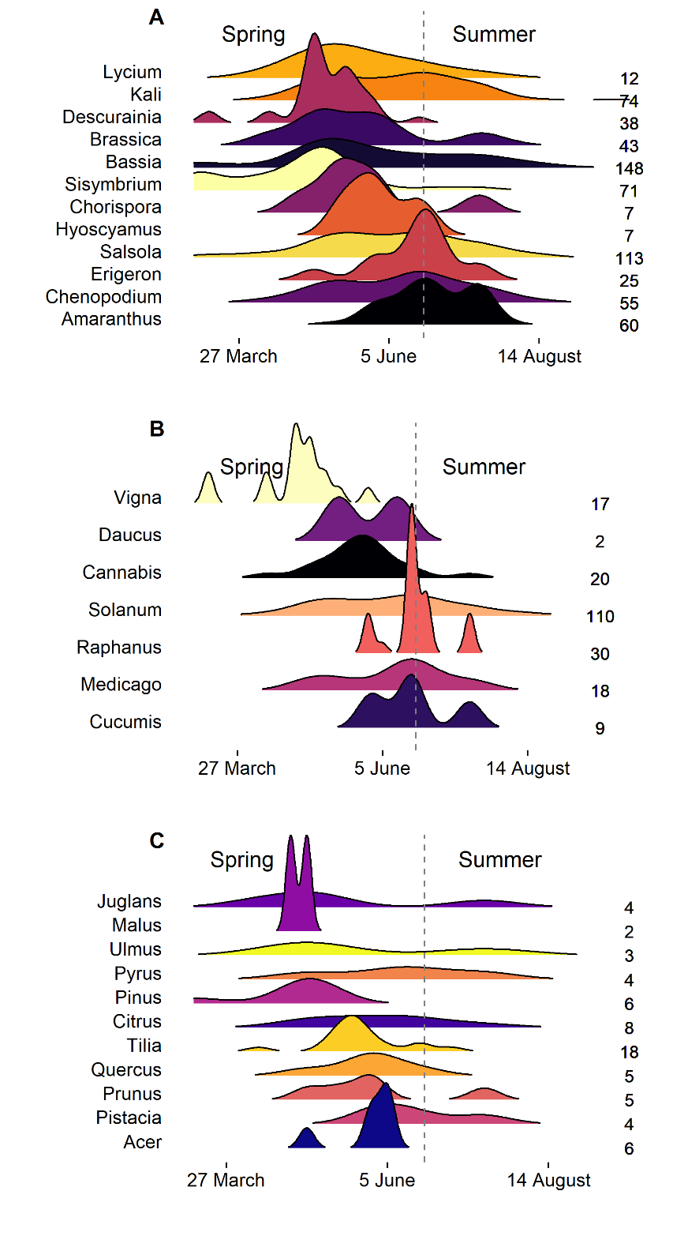
Figure 4. Seasonality of N. tenellus Gut Content Analysis. Genus-level seasonal distributions of plants detected in N. tenellus gut contents, grouped into A) non-crops, B) crops, and C) trees. The x-axis represents the collection date of leafhopper samples, while the y-axis lists the plant genera identified. The vertical dashed line corresponds to 21 June. The magnitude of the ridges represent density at each timepoint proportional to the sample size of each genus (numbers to the right of ridges). Genera with small sample sizes will have larger magnitudes and greater uncertainty of the true seasonal distribution.
SUPPLEMENTAL FIGURE - 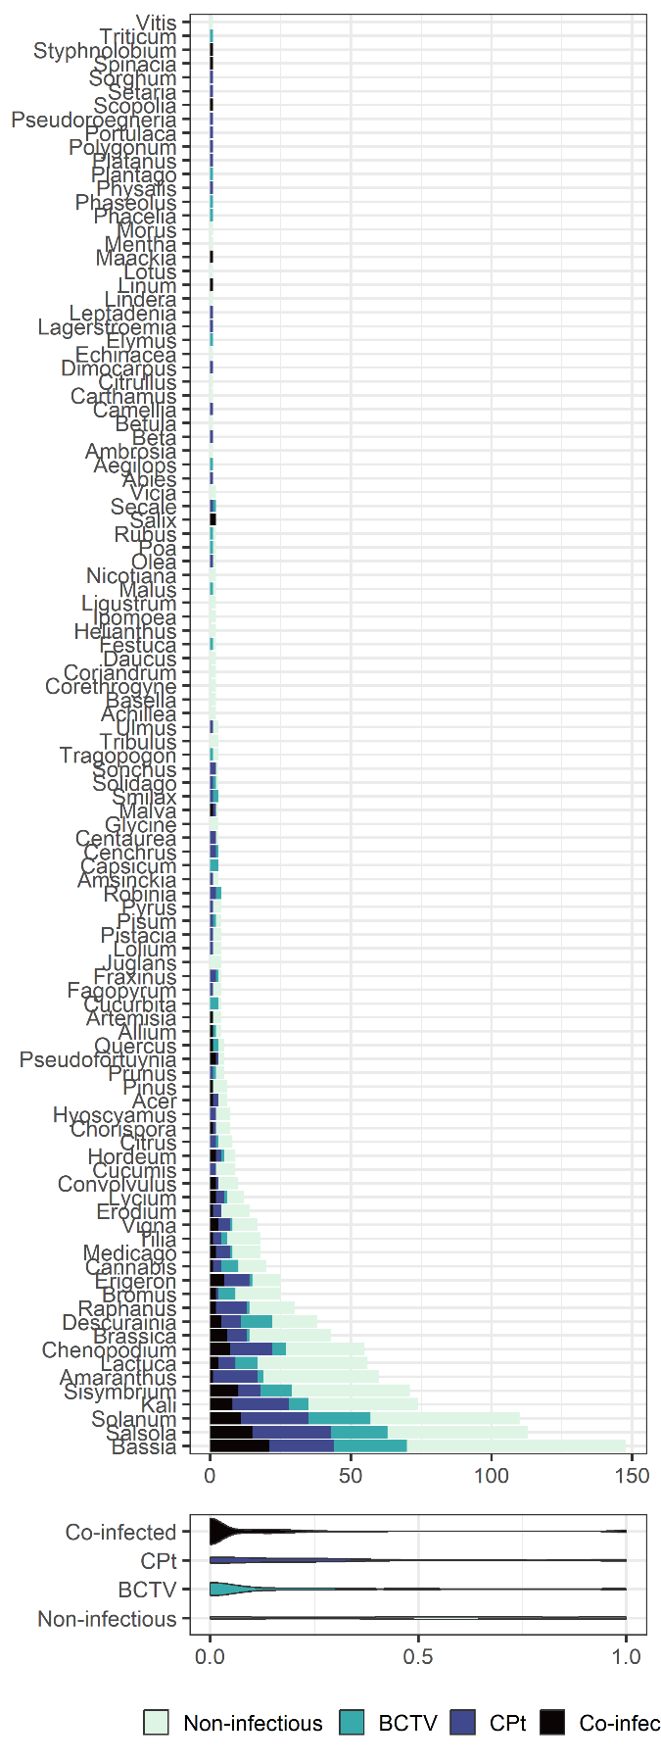
Supplemental Figure. Count of all Plant Genera found in Gut Contents. Counts of all plant genera identified in leafhopper gut contents, stratified by pathogen infection status of N. tenellus.
TABLE 2 –
Factor | df | ∑(squares) | R² | F | P
Sample data (spline) | 5 | 10.0 | 0.16 | 10.3 | < 0.0001
BCTV | 1 | 0.70 | 0.01 | 3.62 | 0.01
Year | 2 | 8.16 | 0.13 | 21.0 | < 0.0001
CPt | 1 | 0.28 | 0.00 | 1.44 | 0.30
Region | 4 | 1.07 | 0.02 | 1.38 | 0.38
BCTV × Year | 2 | 0.63 | 0.01 | 1.63 | 0.23
Residual | 211 | 41.0 | 0.66 | - | -
Total | 226 | 61.8 | 1.00 | - | -

Table 2. Summary statistics from a PERMANOVA fitting a matrix of plant community composition in N. tenellus guts as a function of sample date (a spline term with df = 5), BCTV infection status, collection year, CPt infection status, collection region, and the BCTV x year interaction. The host plant from which each N. tenellus collected was used to stratify the PERMANOVA with a random intercept.

TABLE 1 – (see attached excel TABLE2_plant_table.csv)
Family | Genus | Detections | Percent
Solanaceae | Solanum | 232 | 17.83
Amaranthaceae | Bassia | 148 | 11.38
Amaranthaceae | Salsola | 113 | 8.69
Amaranthaceae | Kali | 74 | 5.69
Brassicaceae | Sisymbrium | 71 | 5.46
Amaranthaceae | Amaranthus | 60 | 4.61
Asteraceae | Lactuca | 56 | 4.3
Amaranthaceae | Chenopodium | 55 | 4.23
Brassicaceae | Brassica | 43 | 3.31
Brassicaceae | Descurainia | 38 | 2.92
Brassicaceae | Raphanus | 30 | 2.31
Asteraceae | Erigeron | 25 | 1.92
Poaceae | Bromus | 25 | 1.92
Cannabaceae | Cannabis | 20 | 1.54
Fabaceae | Medicago | 18 | 1.38
Malvaceae | Tilia | 18 | 1.38
Fabaceae | Vigna | 17 | 1.31
Geraniaceae | Erodium | 14 | 1.08
Solanaceae | Lycium | 12 | 0.92
Convolvulaceae | Convolvulus | 10 | 0.77
Cucurbitaceae | Cucumis | 9 | 0.69
Poaceae | Hordeum | 9 | 0.69
Rutaceae | Citrus | 8 | 0.61
Brassicaceae | Chorispora | 7 | 0.54
Solanaceae | Hyoscyamus | 7 | 0.54
Pinaceae | Pinus | 6 | 0.46
Sapindaceae | Acer | 6 | 0.46
Brassicaceae | Pseudofortuynia | 5 | 0.38
Fagaceae | Quercus | 5 | 0.38
Rosaceae | Prunus | 5 | 0.38
Amaryllidaceae | Allium | 4 | 0.31
Anacardiaceae | Pistacia | 4 | 0.31
Asteraceae | Artemisia | 4 | 0.31
Cucurbitaceae | Cucurbita | 4 | 0.31
Fabaceae | Pisum | 4 | 0.31
Fabaceae | Robinia | 4 | 0.31
Juglandaceae | Juglans | 4 | 0.31
Oleaceae | Fraxinus | 4 | 0.31
Poaceae | Lolium | 4 | 0.31
Polygonaceae | Fagopyrum | 4 | 0.31
Rosaceae | Pyrus | 4 | 0.31
Solanaceae | Physalis | 4 | 0.31
Asteraceae | Centaurea | 3 | 0.23
Asteraceae | Solidago | 3 | 0.23
Asteraceae | Sonchus | 3 | 0.23
Asteraceae | Tragopogon | 3 | 0.23
Boraginaceae | Amsinckia | 3 | 0.23
Fabaceae | Glycine | 3 | 0.23
Malvaceae | Malva | 3 | 0.23
Poaceae | Cenchrus | 3 | 0.23
Smilacaceae | Smilax | 3 | 0.23
Solanaceae | Capsicum | 3 | 0.23
Ulmaceae | Ulmus | 3 | 0.23
Zygophyllaceae | Tribulus | 3 | 0.23
Apiaceae | Coriandrum | 2 | 0.15
Apiaceae | Daucus | 2 | 0.15
Asteraceae | Achillea | 2 | 0.15
Asteraceae | Corethrogyne | 2 | 0.15
Asteraceae | Helianthus | 2 | 0.15
Basellaceae | Basella | 2 | 0.15
Convolvulaceae | Ipomoea | 2 | 0.15
Fabaceae | Vicia | 2 | 0.15
Oleaceae | Ligustrum | 2 | 0.15
Oleaceae | Olea | 2 | 0.15
Poaceae | Festuca | 2 | 0.15
Poaceae | Poa | 2 | 0.15
Poaceae | Secale | 2 | 0.15
Rosaceae | Malus | 2 | 0.15
Rosaceae | Photinia | 2 | 0.15
Rosaceae | Rubus | 2 | 0.15
Salicaceae | Salix | 2 | 0.15
Solanaceae | Nicotiana | 2 | 0.15
Amaranthaceae | Beta | 1 | 0.08
Amaranthaceae | Spinacia | 1 | 0.08
Apocynaceae | Leptadenia | 1 | 0.08
Asteraceae | Ambrosia | 1 | 0.08
Asteraceae | Carthamus | 1 | 0.08
Asteraceae | Echinacea | 1 | 0.08
Betulaceae | Alnus | 1 | 0.08
Betulaceae | Betula | 1 | 0.08
Boraginaceae | Phacelia | 1 | 0.08
Cucurbitaceae | Citrullus | 1 | 0.08
Fabaceae | Lotus | 1 | 0.08
Fabaceae | Maackia | 1 | 0.08
Fabaceae | Phaseolus | 1 | 0.08
Fabaceae | Styphnolobium | 1 | 0.08
Lamiaceae | Mentha | 1 | 0.08
Lauraceae | Lindera | 1 | 0.08
Lauraceae | Phoebe | 1 | 0.08
Linaceae | Linum | 1 | 0.08
Lythraceae | Lagerstroemia | 1 | 0.08
Morceae | Morus | 1 | 0.08
Pinaceae | Abies | 1 | 0.08
Plantaginaceae | Plantago | 1 | 0.08
Platanaceae | Platanus | 1 | 0.08
Poaceae | Aegilops | 1 | 0.08
Poaceae | Elymus | 1 | 0.08
Poaceae | Pseudoroegneria | 1 | 0.08
Poaceae | Setaria | 1 | 0.08
Poaceae | Sorghum | 1 | 0.08
Poaceae | Triticum | 1 | 0.08
Polygonaceae | Polygonum | 1 | 0.08
Portulacaceae | Portulaca | 1 | 0.08
Sapindaceae | Dimocarpus | 1 | 0.08
Solanaceae | Scopolia | 1 | 0.08
Theaceae | Camellia | 1 | 0.08
Vitaceae | Vitis | 1 | 0.08

Table 1. List of plants found in N. tenellus guts and their absolute and proportional abundances.

